Personal Reflection Report

ST20166622/ CIS4014 / WRIT2

# Introduction

As a pair, Alison and I produced an infographic and interactive storyboard to illustrate and describe patterns and trends observed in data relating to the UK’s gender pay gap. The project required us to leverage a wide range of skills, from interpersonal communication and presentation to data analysis and visualisation. The project gave us both the opportunity to share and develop our skills and learn from each other.

We split the project into three phases: data exploration, analysis and design. In the first phase, we examined the available datasets individually, sharing any points of interest we identified. In the second phase, we agreed upon which hypotheses to pursue in order to tell a compelling story, and began to select, transform and visualise relevant areas of the data in order to test them. Finally, we came together to create the overall layout of the infographic and story for the storyboard.

# Role

My primary role within the project was to direct it and push it forward. Alison and I worked well together because she is detail orientated and I am driven by big ideas and stories, so each week I would present her with lots of ideas for visuals and storyboards, and she would identify their strengths and weaknesses. As a team this meant that we were producing interesting and innovative visuals that were also accurate, truthful and relevant. As part of my role in directing the project, I performed most of the literature review to supplement our data analysis, which helped to direct our enquiries and formed the discussion elements of our infographic and storyboard.

Initially we were a group of three, at which point we agreed that I would be responsible for the interactive storyboard and the other two group members would produce the infographic. I wanted to be responsible for the storyboard because creating an interactive visual would give me an opportunity to develop my coding skills, and because I have many years of experience of public speaking so I was confident that I could deliver a concise and compelling verbal presentation.

Early in the project, however, one group member left, so I took on additional responsibility for producing the infographic. Being experienced with visual communication I focused mostly on directing the look and feel of the infographic, as well as creating some of the charts and the chloropleth.

# Reflection

## My skills

My background is in science communication, and from my experience in writing and presenting scientific shows I have developed many relevant skills that I applied throughout this project. My oral presentation skills include public speaking and storytelling, as well as ensuring that content is relevant to the audience. Most importantly, I am confident speaking in front of an audience, and I enjoy it.

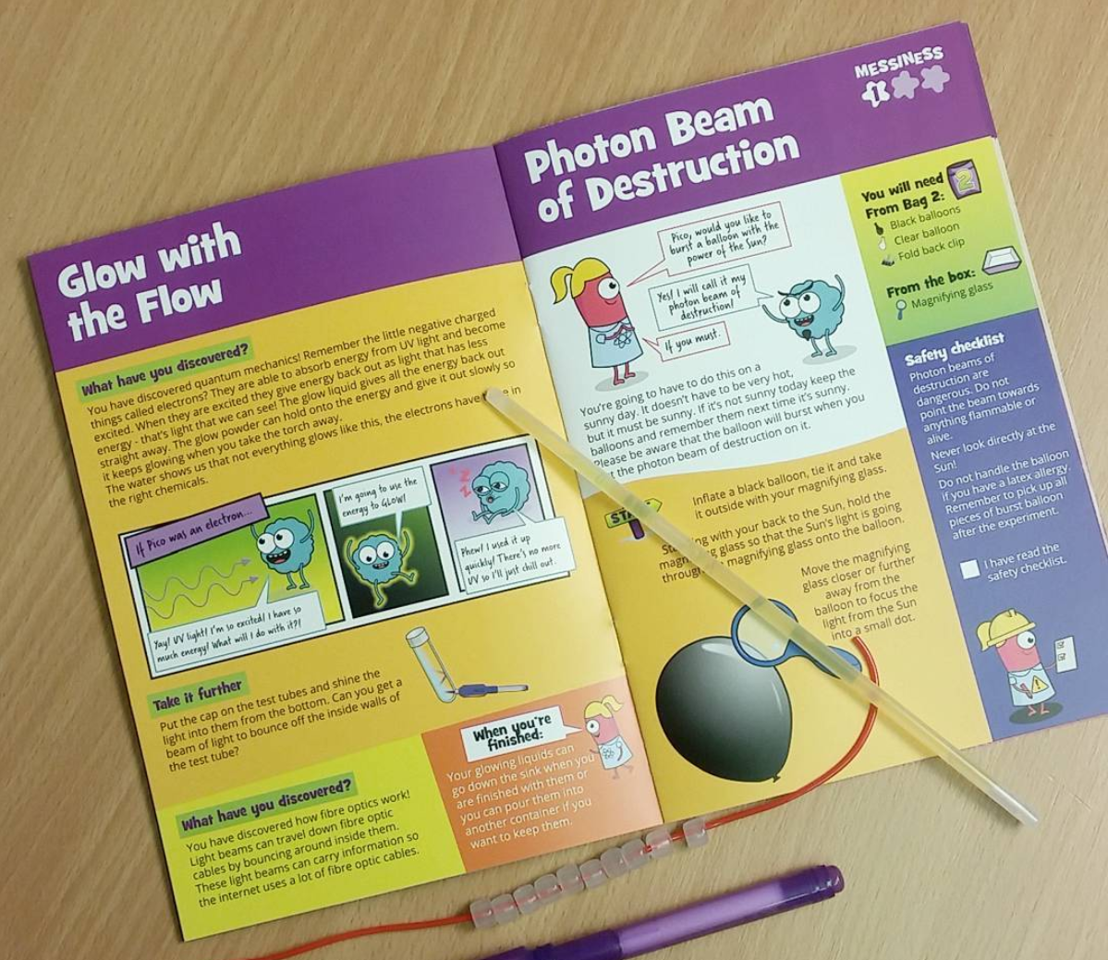I also have experience of graphic communication, having produced a series of educational booklets for children (as shown in Figure 1). This experience, supplemented by Adobe InDesign training and reading Alberto Cairo’s *The Truthful Art* (2016) and Cole Nussbaumer Knaflic’s *Storytelling with Data : A Data Visualization Guide for Business Professionals* (Nussbaumer Knaflic, 2015), has equipped me with keen attention to detail, creativity, innovation, and aptitude for visual design tools such as Visme.

Figure 1 An example of my previous experience in graphic communication. Image credit: Letterbox Lab (2017)

Being a science graduate, I have some experience in data analysis and am confident using Excel to create charts. I have been learning to use R Studio for data analysis as part of my job and feel that I have some basic skills in using R to generate static and interactive charts.

## My strengths

My key strengths are in producing coherent stories and visually appealing graphics. Because I have experience in science communication, I am confident talking about complex topics in an audience-appropriate manner, and in balancing technical detail with key messages. Being experienced in producing presentations – both oral and visual – that communicate complex ideas, I have strong project management skills that helped to drive the project forward and ensure that we did not let minor details obscure the key messages of the presentation.

## My weaknesses

The part of the project that I found most challenging was the data analysis; this is an area of weakness for me as I have very little experience of working with large, complex datasets such as the ones used for the project. My partner helped me to improve these skills by checking the graphs and tables that I produced, and her guidance helped us to ensure that we were making sensible assumptions and transformations to produce visuals and identify trends. Another area of weakness for me was in creating interactive visuals; we both struggled to use python to create a chloropleth chart so instead used a tool provided in Visme (Visme, 2019).

## My contributions

Throughout the project my focus was on bringing together the results of the analysis to produce a coherent presentation that flowed from a concise and cogent talk to a visually appealing infographic.

Selecting an appropriate dataset to study was the most challenging part of the project, as my partner’s line manager had requested that we use data from Companies House. Unfortunately, the only publicly available data from Companies House was a list of registered companies in the UK, from which we struggled to extract suitable variables for study. Eventually we agreed to use the Gender Pay Gap service (Gender Pay Gap Service, 2019) because it related to companies, but this dataset also proved challenging. Without strong data analysis skills I struggled to identify bottlenecks from the available data, and my partner was similarly impeded by time restraints. Since my research skills are stronger than my analysis skills, while I waited for my partner to investigate the Gender Pay Gap Service data I identified other relevant data sources to use, including the ONS dataset (Office of National Statistics, 2019).

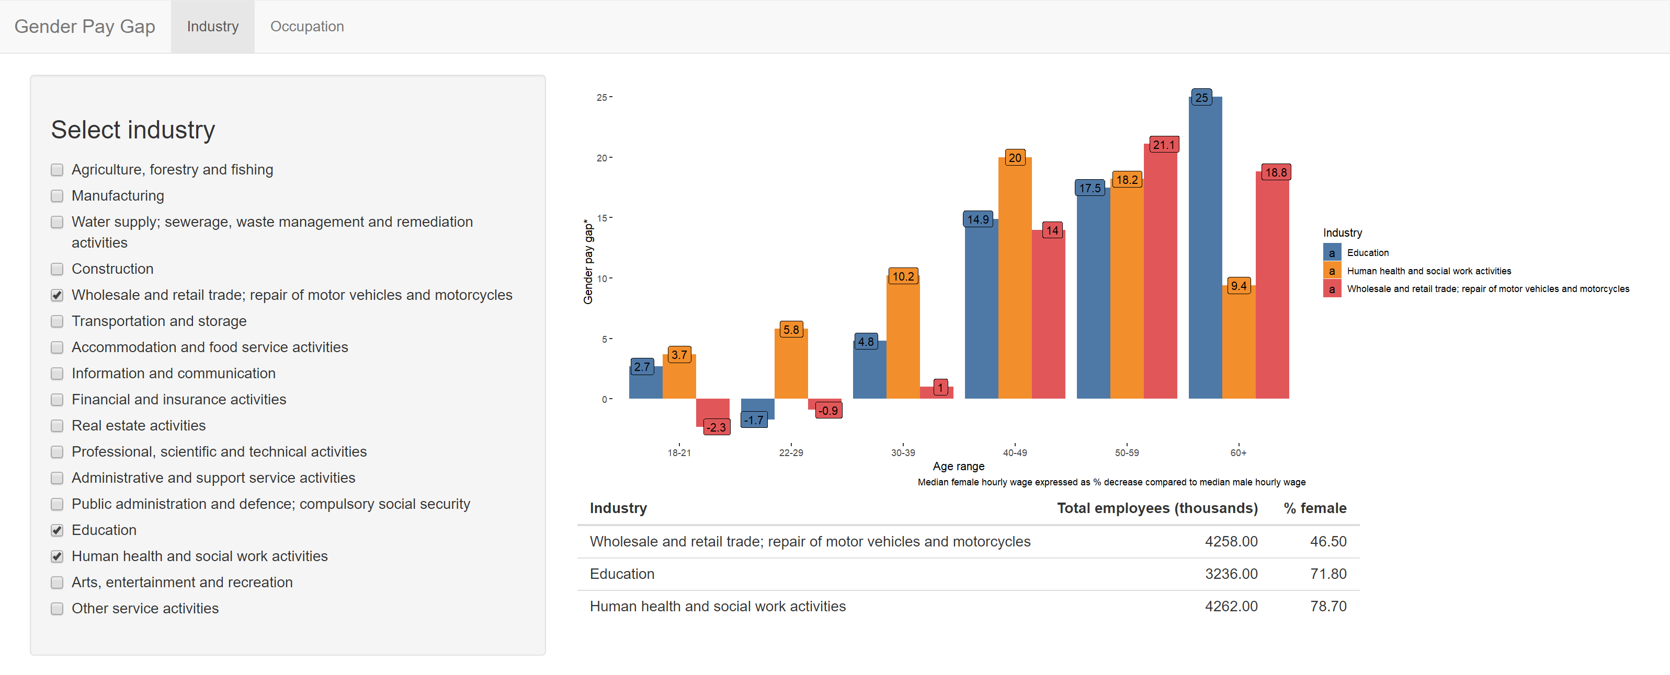

Figure 2 A shiny app created to assist with data exploration. The 'Occupation' tab leads to a similar dashboard with industries replaced with occupations

I used R to explore the datasets, identifying several trends that we went on to communicate in the presentation. I learned how to create a Shiny app (R Studio, 2019), shown in in Figure 2, to allow visual exploration of the median gender pay gap across the different industries, occupations and age groups in the ONS data. This helped me to identify that the gender pay gap increases with age for most industries. I also compared the gender pay gap of full-time workers to that of part-time workers and identified that the pay gap of the former was significantly larger.

After we had both investigated these datasets we selected hypotheses to test and identified bottlenecks and trends that we would communicate in the presentation. We were both agreed that age should be considered as a factor affecting the gender pay gap, In addition, I suggested including information about the gender pay gap across several industries, and Alison suggested including information about part-time workers and geographical information. I produced several visuals for the infographic, shown in Figures 3 and 4, and two interactive visuals to use in the oral presentation, shown in Figures 5 and 6.

Alongside producing these visuals, I researched the gender pay gap to identify its causes and potential solutions. This research was incorporated into both the infographic and the presentation. After we had agreed upon the layout of the infographic and narrative of the oral presentation, I used Visme (Visme, 2019) to produce the infographic and Story Map Cascade (Esri, 2019) to create the visual element of the talk. Finally, I delivered the oral presentation, sharing responsibility for answering questions with Alison.

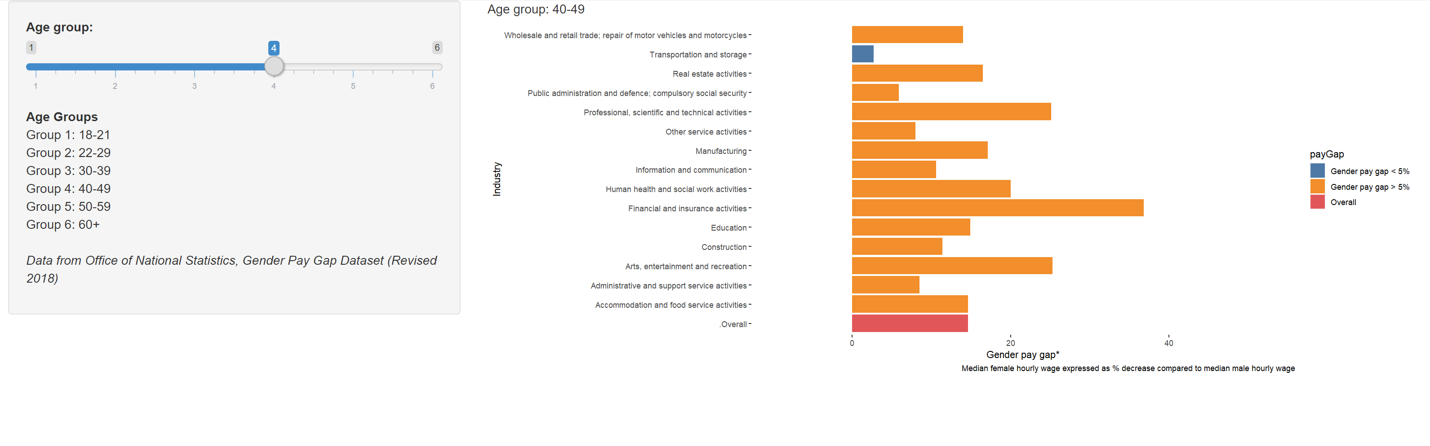

Figure 6 Interactive chart used to explore gender pay gap across several industries for different age groups, produced using R Shiny

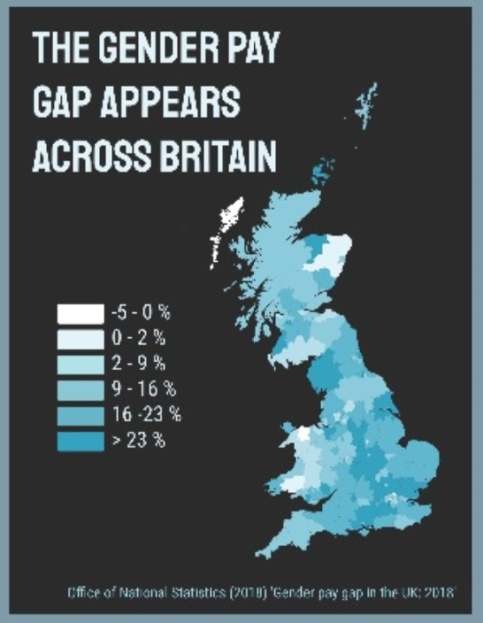

Figure 3 Chloropleth chart produced using Visme's inbuilt map tool

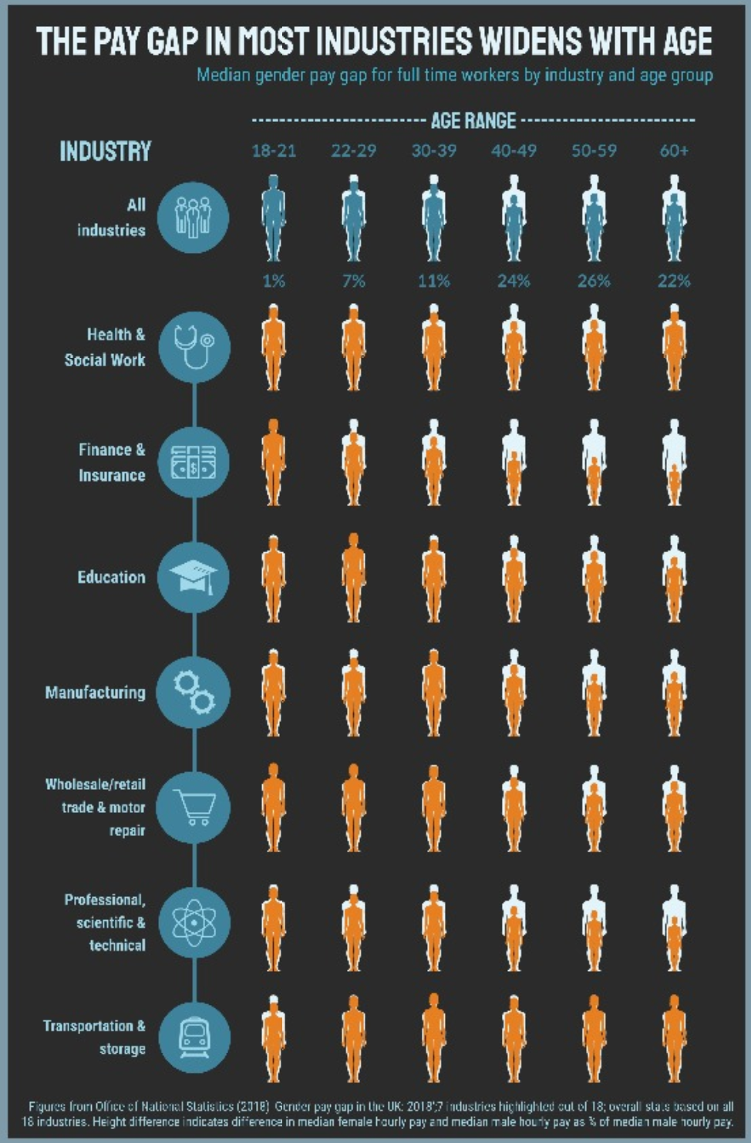

Figure 4 Chart comparing gender pay gap between several industries for different age groups, produced manually using Visme

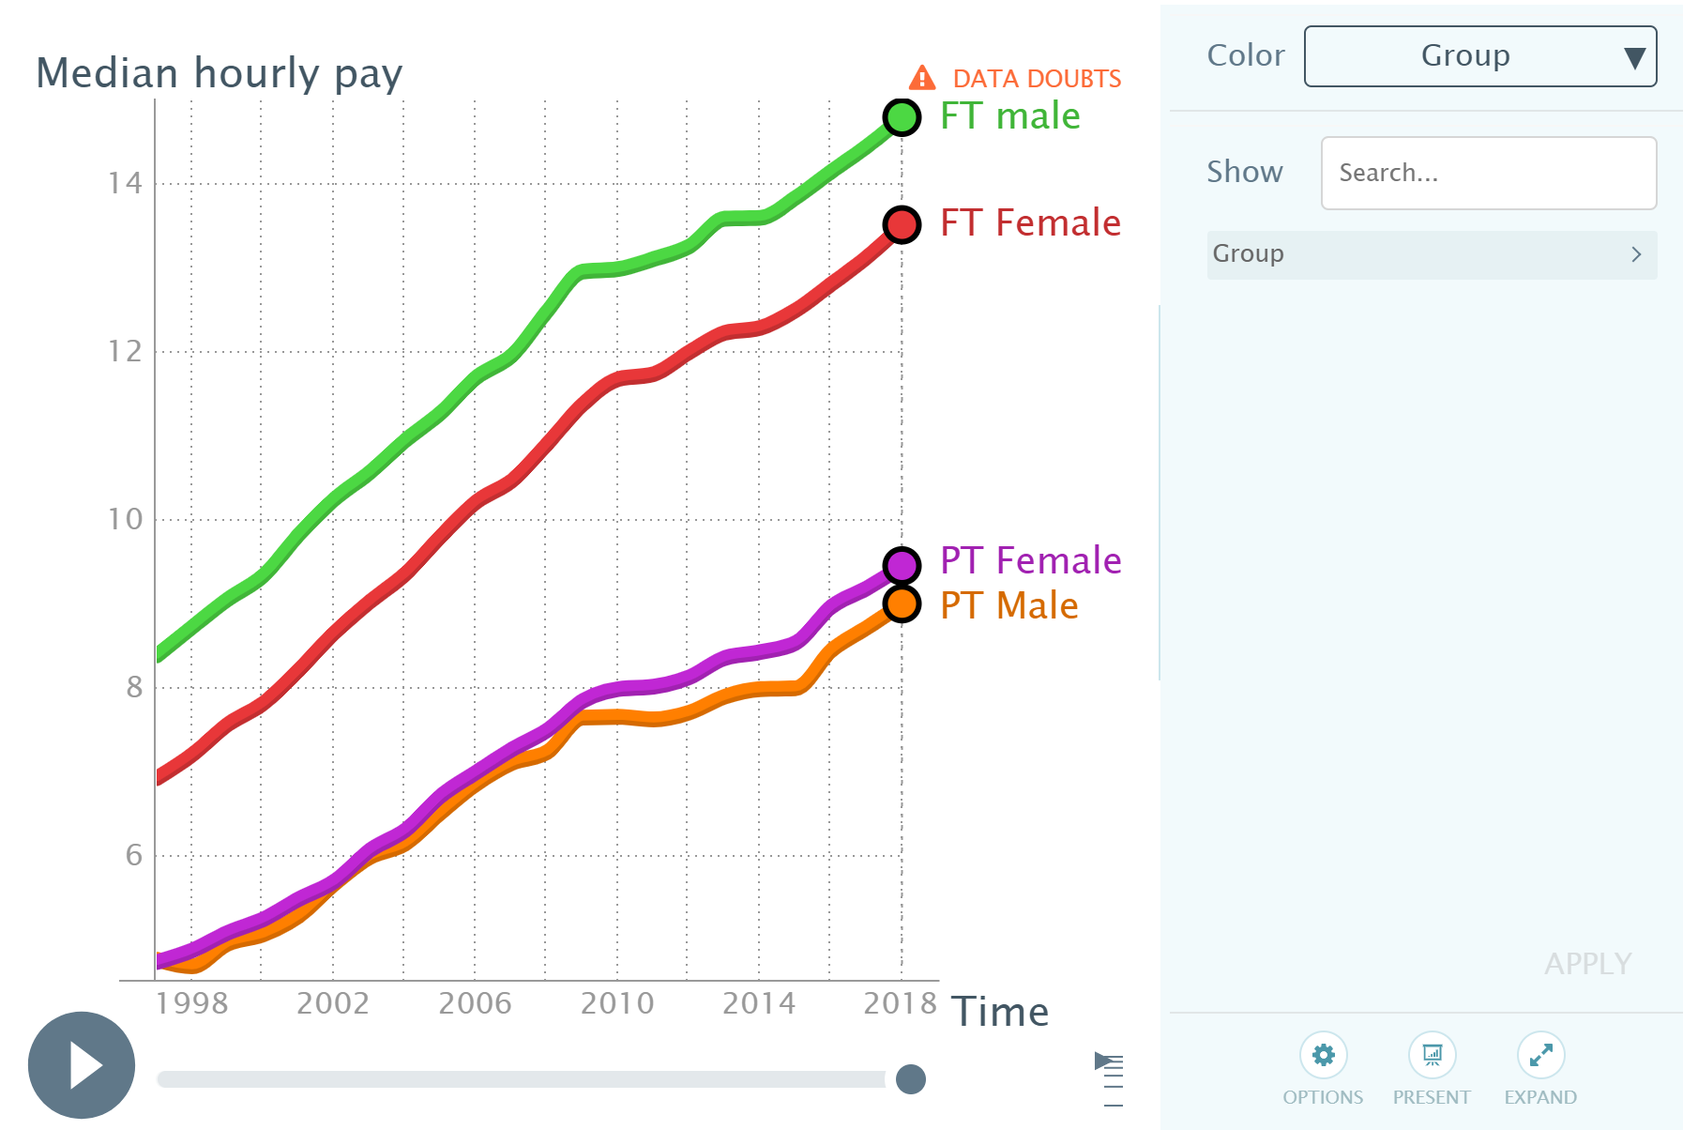

Figure 5Interactive time series animation produced using Gapminder

# Presentation

Our strategy for the ten-minute oral presentation was to give a concise overview of the background to the gender pay gap, the trends we had identified and additional research to support our data, focusing on the key bottleneck of motherhood impacting female workers’ pay from the 30-39 age group onwards. In designing the Story Map Cascade I chose to keep the text minimal so as not to distract the audience, and surrounded the data with relevant imagery that complimented the tone and message of each part of the presentation. The Gapminder time series animation (Figure 4) was included in the presentation to give a clear overview of the gender pay gap over the last two years, and to highlight succinctly the difference in the pay gap between full-time and part-time workers. The Shiny App (Figure 5) was included because it allowed us to quickly and concisely highlight the different pay gaps among workers in different industries and age groups.

Our objective for the infographic was to create something that would attract an audience and invite them to explore intricate details of the gender pay gap. To attain this, I selected a muted colour scheme (black, grey and teal) with a contrasting accent colour (orange). Before creating any graphics, we agreed upon a narrative flow from the top to the bottom. The graphics at the top were generally descriptive of the gender pay gap and its variation across age groups, industries and locality. Further down we suggested reasons for the gender pay gap in the UK in a section surrounded by data that supported our hypotheses: the evidence from the study by Kleven, et al. (2018); the chart outlining the difference between the gender pay gaps for full-time and part-time workers, and the distribution of male and female workers in the pay quartiles from the Gender Pay Gap Service data (Gender Pay Gap Service, 2019). We then worked individually to create the charts, and I produced the infographic from the different elements, ensuring that the colour scheme, fonts and tone was consistent throughout.

# Way forward

Of all the skills I used in this project, I would most like to improve my data visualisation skills. Choosing graphic forms to include in the infographic and interactive charts to use for the storyboard was the most interesting part of the project for me as it gave me the opportunity to develop my creativity and innovation skills. However, I feel I have a great deal of room for improvement in data visualisation and I am progressing by reading more books about data visualisation (including Andy Kirk’s *Data Visualisation* (2019)and more technical books, such as Garrett Grolemund and Hadley Wickham’s *R for Data Science* (2017).

Having had trouble using python to create a chloropleth chart, I would also like to develop my python skills further. Towards this end I will continue investigating the gender pay gap data using python for practice.

I enjoyed creating the infographic much more than I expected, and I will endeavour to continue visualising data that interests me, so as to communicate – and hopefully pass on - that interest to others.

# References

Cairo, A., 2016. *The Truthful Art: Data, charts and maps for communication.* San Francisco: New Riders.

Esri, 2019. *Story Map Cascade.* [Online]   
Available at: http://storymaps-classic.arcgis.com/en/app-list/cascade/  
[Accessed December 2019].

Gender Pay Gap Service, 2019. *Download gender pay gap data - Reporting year 2018-2019.* [Online]   
Available at: https://gender-pay-gap.service.gov.uk/  
[Accessed December 2019]

Grolemund, G. & Wickham, H., 2017. *R for Data Science.* Sebastopol: O'Reilly.

Kirk, A., 2019. *Data Visualisation: a handbook for data driven design.* 2nd ed. London: Sage.

Kleven, H., Landais, C. & Søgaard, J. E., 2018. Children and Gender Inequality: Evidence from Denmark. *NBER Working Paper No. 24219.*

Letterbox Lab, 2017. *Explore Box 5: Go with the Glow, via Instagram [Online]  
Available at:*https://www.instagram.com/p/BXiQj6tACzZ/   
[Accessed December 2019]

Nussbaumer Knaflic, C., 2015. *Storytelling with Data : A Data Visualization Guide for Business Professionals.* 1 ed. Hoboken, NJ, USA.: John Wiley & Sons, Incorporated.

Office of National Statistics, 2019. *ONS Dataset: Gender Pay Gap.* [Online]   
Available at: https://www.ons.gov.uk/employmentandlabourmarket/peopleinwork/earningsandworkinghours/datasets/annualsurveyofhoursandearningsashegenderpaygaptables  
[Accessed December 2019].

R Studio, 2019. *Shiny from R Studio.*

Sigurðardóttir, G. H., 2019. *Parental leave in Iceland gives dad a strong position.* [Online]   
Available at: http://www.nordiclabourjournal.org/i-fokus/in-focus-2019/future-of-work-iceland/article.2019-04-11.9299118347  
[Accessed December 2019].

Visme, 2019. *Free Infographic Software and Presentation Maker.* [Online]   
Available at: visme.co  
[Accessed December 2019].